**Virtual School Library Lesson**

**Gingerbread Extension Activity**

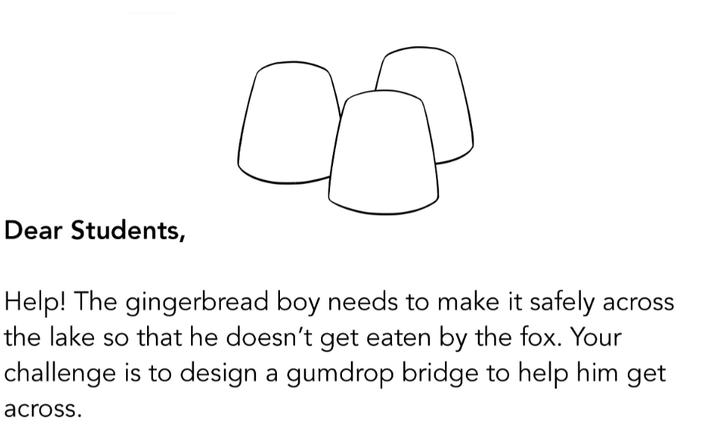

Ask your mom to buy you some gumdrops (good gooey candy) and some toothpicks. About 30 gumdrops and 60 toothpicks should do the trick!

